**IMAGE BASED CALORIE CALCULATOR**

Submitted in partial fulfillment of the requirements

of the degree of

**BACHELOR OF ENGINEERING**

**In**

**COMPUTER ENGINEERING**

By

Group No: 10

Roll No. Name

1204086 Sagar Mistry

1204092 Anirudh Mundra

1204093 Shubham Munot

Supervisor:

Dr. Archana Patankar

(Associate Professor, Computer Engineering Department, TSEC)



Computer Engineering Department

Thadomal Shahani Engineering College

University of Mumbai

2015-2016

**CERTIFICATE**

This is to certify that the project entitled **“IMAGE BASED CALORIE CALCULATOR”** is a bonafide work of

Roll No. Name

1204086 Sagar Mistry

1204092 Anirudh Mundra

1204093 Shubham Munot

submitted to the University of Mumbai in partial fulfillment of the requirement for the award of the degree of **“BACHELOR OF ENGINEERING”** in **“COMPUTER ENGINEERING”**.

_________________________

Dr. Archana Patankar

Supervisor/Guide

_________________________ _________________________

Mr. Jayant Gadge Dr. G.T. Thampi

Head of Department Principal

Project Report Approval for B. E

Project report entitled ***IMAGE BASED CALORIE CALCULATOR*** by

Roll No. Name

1204086 Sagar Mistry

1204092 Anirudh Mundra

1204093 Shubham Munot

is approved for the degree of ***“BACHELOR OF ENGINEERING” in “COMPUTER ENGINEERING”****.*

Examiners

1.---------------------------------------------

2.---------------------------------------------

Date:

Place:

Declaration

I declare that this written submission represents my ideas in my own words and where others' ideas or words have been included, I have adequately cited and referenced the original sources. I also declare that I have adhered to all principles of academic honesty and integrity and have not misrepresented or fabricated or falsified any idea/data/fact/source in my submission. I understand that any violation of the above will be cause for disciplinary action by the Institute and can also evoke penal action from the sources which have thus not been properly cited or from whom proper permission has not been taken when needed.

1)

____________________

Sagar Mistry (1204086)

2)

____________________

Anirudh Mundra (1204092)

3)

____________________

Shubham Munot (1204093)

Date:

**Abstract**

In a world of self [consciousness](https://www.google.co.in/search?safe=active&es_sm=122&q=consciousness&spell=1&sa=X&ved=0CBoQvwUoAGoVChMIlZnMuNqmyAIVVAiOCh1sZwVe), people are thriving for beauty as well as brains. Ultimately everything narrows down to the diet you have. The nutrients, calories, vitamins of the diet have a profound impact on our health. Technology has always aided to solve our real world problems. Considering “How many calories am I consuming in my meal?” as the real world problem, we have proposed a methodology “Image Based Calorie Calculator” of calculating the calories of the ingredients of your meal. Ingredients are the whole food items you will be using to prepare the meal.

Having clicked an image of all these ingredients, with the help of image processing concepts we will be able to provide you with an approximate calorie value. The user can now gauge whether his meal is fit for him or changes are required. Image having several ingredients will go through the segmentation process initially, to isolate every object. Followed by feature extraction methodology to identify each item, calories would be calculated by using a predefined nutrition table.

**Table of Contents**

**Sr No. Topic Page No.**

Abstract i

Table of Contents ii

List of Figures iii

Chapter 1 **Introduction**  **1-2**

1.1 Introduction 1

1.2 Aim & Objectives 2

1.3 Scope 2

Chapter 2 **Review of Literature**  **3-6**

2.1 Domain Explanation 3

2.2 Existing Solution 3

2.3 Hardware and Software Requirements 6

Chapter 3 **Analysis 7-9**

3.1 Functional Requirements 7

3.2 Non-Functional Requirements 7

3.3 Proposed System 8

Chapter 4 **Design 10-16**

4.1 Design Consideration 10

4.2 Design Details 11

4.3 GUI Design 16

Chapter 5 **Implementation Plan 17**

**References**   **18**

**Acknowledgement 19**

**List of Figures**

**No. Figure Page No.**

2.1 Flowchart of Existing System 5

3.1 Flowchart of Proposed System 9

4.1 Shadow Removal 12

4.2 LBG for Two Dimensional case 13

4.3 Nutrition Table 15

4.4 Input Image 15

4.5 Screen 1 (Input) 16

4. 6 Screen 2 (Output) 16

**Chapter 1**

**Introduction**

**1.1 Introduction**

Heavy storage of digital media, often containing both images and videos is an outcome of growing needs facilitated by modern technology. Providing metadata to images, describing the image content can make it easier to find images of interest, but loses its efficiency with respect to time and cost.

CBIR has provided an automated way to retrieve images based on the content or features of the images itself. Having an image consisting of several items in it, a segmentation algorithm could be applied in order to isolate each item and then process each of them individually. The CBIR system simply extracts the content of the query image matches them to contents of the search image. CBIR is defined as a process to find similar picture or pictures in the image database when a query image is given. Often the image is required to resized, to the database standard size. On doing so the query image could be compared in a better way to the retrieved results. Given a picture of an apple, the system should be able to consider all similar images of an apple in the database. This is done by extracting the features of the images such as color, texture and shape. There will be 5-10 images of every food item in the database, and feature vector would be calculated of each of those images. Ultimately, a final average feature vector of the corresponding food item would be generated. These feature vectors are used to compare between the query image and images in the database. A similarity algorithm is used to calculate the degree of similarity between those two images. Images in the database which has similar images features to the query image are considered for further processing. After finalizing the images from the database, and coming on to the result of what the food item is, calorie value would be mapped from the predefined nutrition table.

As people across the world are becoming more focused on their health it is necessary to keep a track of their diet. It is obvious that eating food with high amount of calories can cause several problems to our health. Although the people can record their meal and discuss with doctors or experts, it is not so convenient and they cannot know the amount of calories before the meal[3]. Thus, “Image Based Calorie Calculator” technique would aid the user to know the calorie value of his meal’s ingredients.

**1.2 Aim and Objective**

The aim of the Calorie Calculator project is to use Content Based Image Retrieval technology to identify and segment different types of elements that are in the image captured by the user. It is an approach which works by first segmenting and then processing it individually. Feature vectors extracted from the user image is compared with the images in the database to identify them. The entire process involves several steps including Pre-Processing, Segmentation, Feature Extraction and Calorie Computation.

**1.3 Scope**

The scope of our project " Image Based Calorie Calculator " is to use a new approach in order to help the users to find out the calories they consume by merely just clicking the picture of their meal. To demonstrate, the proposed approach we will be implementing it using MATLAB. Around 12-15 food items have been selected including fruits and vegetables. Input images containing food items from the mentioned dataset will be detected. An item not mentioned in the dataset would produce a result saying "Item not present in the database."

**Chapter 2**

**Review of Literature**

**2.1 Domain Explanation**

The following project comes under the domain of 'Image Processing'. It uses Content Based Image Retrieval approach to calculate the amount of calories of your meal ingredients.

Digital image processing  is the use of computer [algorithms](https://en.wikipedia.org/wiki/Algorithm) to perform [image processing](https://en.wikipedia.org/wiki/Image_processing) on [digital images](https://en.wikipedia.org/wiki/Digital_image). Content-based image retrieval (CBIR), also known as query by image content (QBIC) and content-based visual information retrieval (CBVIR) is the application of [computer vision](https://en.wikipedia.org/wiki/Computer_vision) techniques to the [image retrieval](https://en.wikipedia.org/wiki/Image_retrieval) problem, that is, the problem of searching for [digital images](https://en.wikipedia.org/wiki/Digital_image) in large databases. It opposed to the traditional method of assigning meta data to every image in the database.

The most common method for comparing two images in content-based image retrieval (typically an example image and an image from the database) is using an image distance measure. An image distance measure compares the similarity of two images in various dimensions such as color, texture, shape, and others. For example a distance of 0 signifies an exact match with the query, with respect to the dimensions that were considered. As one may intuitively gather, a value greater than 0 indicates various degrees of similarities between the images. Search results then can be sorted based on their distance to the queried image. Many measures of image distance (Similarity Models) have been developed. Extracting the feature vector from the input image we would be able to implement CBIR technique to identify the what the particular food item would be.

**2.2 Existing Solutions**

Many approaches are available in literature for content based image retrieval based on various techniques and choice of desired image components for feature extraction. Various image components like color, texture, shape, semantic image have proven useful for image retrieval methods. Food recognition exposes new challenges to the current pattern recognition literature and stimulates the stemming of novel techniques for general object recognition. Many people have tried different algorithms at various phases to achieve efficiency on this topic[1].

At the segmentation phase, each image will be separated into various food portions. To have a considerable segmentation of the image they employed color and texture segmentation tools. For each detected food portion, a feature extraction process has to be performed. In this step, various food features including size, shape, color, and texture will be extracted. The extracted features will be sent to the classification step where, using the support vector machine (SVM) scheme, the food portion will be identified. Finally, by identifying the food item and using some nutritional tables, the calorie value of the food will be extracted.

K-means clustering, is employed for segmentation phase. Clustering is a way to separate group of objects. It treats each object as having a location in space. It finds partitions such that objects within each cluster are as close to each other as possible and as far from objects in other as possible. K means clustering requires number of clusters to be partitioned.

Gabor filter-bank is used for texture feature extraction. The texture features are obtained by subjecting each image to a Gabor filtering operation in a window around each pixel.

The next step is classifying the extracted features in order to recognize each food portion. To do so, SVM is used, which is one of the popular techniques used for data classification. A classification task usually involves training and testing data which consist of some data instances. Each instance in the training set contains one class label and several features. The goal of SVM is to produce a model which predicts the target value of data instances in the testing set which are given only by their attributes[1].

And ultimately, the identified food portion is mapped onto a nutrition table from where the calorie values will be extracted and considered for further calculations.

Input Image

Segmentation Phase

(K-means Clustering)

Feature Extraction Phase

(Gabor Filter Bank)

Data Classification Phase

(Support Vector Machine)

Calorie Computation Phase

(Database Query Processing)

Total Calories

Figure 2.1 Flowchart of Existing System

**2.3 Hardware and Software Requirements**

**2.3.1 Software requirements specifications:**

* Operating System : Windows-7 or higher
* Programming Language : Matlab, Core Java
* User Interface : Swing

**2.3.2 Hardware requirements specifications:**

* Processor : Intel Core 2 Duo or AMD Athlon64X2
* RAM : 4GB
* Memory : 100MB

**Chapter 3**

**Analysis**

**3.1 Functional Requirements**

* The system will take an image as the input, by specifying the file path.
* The user will click an image of the meal ingredients in a plate, as whole items which are not overlapping each other, and the system would perform operations on this image only.
* The system would refine the image by removing unwanted noise and shadows.
* Then system would use clustering algorithm, "Linde-Buzo-Gray", to segment the food items in the image into different elements. Segmentation helps in processing the food items individually.
* Then every food item is resized to 256*256 for uniformity in processing.
* Then system extracts feature by applying Walsh Transformation and then it identifies the food item.
* Using the result of feature extraction, it is then mapped on to the nutrition table, to get the calorie value of the identified food item.

**3.2 Non-Functional requirements**

**3.2.1 Ease of Access**

The system should be cost effective hence it is implemented without any hassle. Also it is doesn't involve any complexity during its use.

**3.2.2 Reliability**

The algorithms used in the system are accurate and produce correct results under certain conditions stated. Hence, the system should provide a right answer is hence reliable.

**3.2.3 Usability**

The system is not complicated and easy to use. Being a user friendly system, it reduces the human effort to find the calorie value of the item and calculate it by themselves.

**3.3 Proposed System**

The proposed system enables one to calculate calories by just clicking picture of their meal ingredients. System maintains a nutrition table of all the food items considered in the scope of the project. Having clicked an image of the meal ingredients in a plate, the system will enter the pre processing phase where the noise and shadows will be removed to get a better image for further phases. Following it, in segmentation phase, the image will be analyzed to extract various segments of the food items. It is known that without having a good image segmentation mechanism, it is impossible to process the image appropriately. Hence we have employed 'Linde-Buzo-Gray' clustering algorithm to segment the food items.

For each detected food item from the segmentation phase, a feature extraction process is performed. In this phase, we use Walsh Column transform to calculate the mean feature vector of the food item. This will be accomplished by applying Walsh Column transform and then calculating the mean of each column, we get a mean vector of food item. We have already extracted mean feature vectors of the food items in our scope. The extracted mean feature vector is then compared with the values from our database to identify the food item[2]. Then the identified food item is mapped with our nutrition table to get the calorie values.

The proposed system has major phases:

1. **Pre-Processing phase**

This phase refines the user image of the meal ingredients by removing noise. Then it also removes shadow to get a better and well contrasted image to work on.

1. **Segmentation phase:**

This phase segments the image into different elements using LBG algorithm. It makes it easier for the system to work of each food item individually. Each food item is then resized to 256*256.

1. **Feature extraction phase:**

This phase extracts feature from each food item segmented from the previous phase. It uses Walsh Transform, and then computes mean feature vector of all the food items from the user image. Pre-Built Database for the food items from the scope is used by comparing them with the mean feature vector of the food items and finally they are identified[2].

1. **Calorie computation phase:**

This phase calculates the calorie for the identified food items. It maps the food items with the nutrition table to get the calorie values.

Input Image

Pre Processing Phase

(Noise Reduction & Shadow Removal)

Segmentation Phase

(LBG Algorithm)

Feature Extraction Phase

(Feature vector generated using Walsh Transform)

Calorie Computation Phase

(Database Query processing)

Total Calories

Figure 3.1 Flowchart of Proposed System

**Chapter 4**

**Design**

**4.1 Design Consideration**

While designing the system, all the previous developments made in the domain, and the potential researches that can be effectively considered, have been taken into account.

1. Efficiently segmenting the user image since all the food items are together. If not segmented, recognition of every individual item in the image would fail. Hence the algorithm should efficiently be able to separate the food items for the correct recognition.
2. Taking intelligent decisions while recognizing food items that are of same color like when food items are apples, tomatoes, pomegranates. Look alike items in the image, should result to a correct answer solely depending upon user discretion.
3. No false detection of any item. If a particular item is not present in the dataset should produce a result, " Item not present in the database" and not give incorrect results.
4. Maintaining a decent accuracy rate to recognize the food items while balancing it with the amount of time taken to retrieve calorie values.
5. Finally the task of retrieving the correct calorie values of the identified food items by mapping them with the nutrition table. Such a result is sensitive and important to the user.
6. The GUI would be user friendly and would just need the image as input. Total calories will be displayed as the final result.

**4.2 Design Details**

**4.2.1 Food Image**

The database would contain images of various food items mentioned in the scope in the .jpg format. The input image will be in the same format.

**4.2.2 Pre processing**

Pre processing is done to reduce noise and remove the shadow. This resulting image would be able to produce better results when processed in the next phases.

**4.2.2.1 Noise Reduction**

Salt-and-pepper noise is a form of [noise](https://en.wikipedia.org/wiki/Image_noise) sometimes seen on images. It presents itself as sparsely occurring white and black [pixels](https://en.wikipedia.org/wiki/Pixel). An effective [noise reduction](https://en.wikipedia.org/wiki/Noise_reduction) method for this type of noise is a [median filter](https://en.wikipedia.org/wiki/Median_filter) or a [morphological filter](https://en.wikipedia.org/wiki/Mathematical_morphology). The main idea of the median filter is to run through the signal entry by entry, replacing each entry with the [median](https://en.wikipedia.org/wiki/Median) of neighboring entries. The pattern of neighbors is called the "window", which slides, entry by entry, over the entire signal.

**4.2.2.2 Shadow Removal**

We have used Standard deviation to remove shadows, if the deviation is too high, it is recognized as shadow and then that pixel is merged with the background pixel. This allows the system to process the image efficiently. With shadows in the image, the results for feature extraction phase can be hampered.

Algorithm:

1. Take the mean RBG value of each pixel
2. Take Euclidean distance of each pixel in 3 different planes.
3. Check the difference of each plane with other two and if all are below an arbitrary constant, then it is merged with the background or else it is element's pixel.

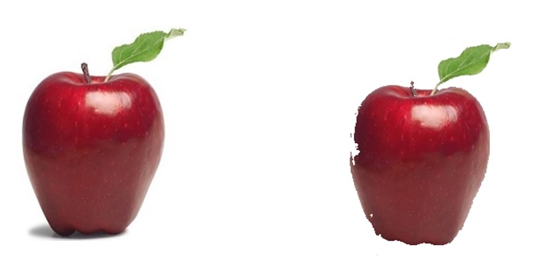

Figure 4.1 Shadow Removal

**4.2.3 Segmentation**

Clustering helps to segment the image into various food portions. Implementing Vector quantization (VQ), which is a classical [quantization](https://en.wikipedia.org/wiki/Quantization_(signal_processing)) technique from [signal processing](https://en.wikipedia.org/wiki/Signal_processing) that allows the modelling of probability density functions by the distribution of prototype vectors. The density matching property of vector quantization is powerful, especially for identifying the density of large and high-dimensioned data. The Linde–Buzo–Gray algorithm (introduced by Yoseph Linde, Andrés Buzo and [Robert M. Gray](https://en.wikipedia.org/wiki/Robert_M._Gray) in 1980) is a [vector quantization](https://en.wikipedia.org/wiki/Vector_quantization) algorithm to derive a good [codebook](https://en.wikipedia.org/wiki/Codebook). A codebook is a type of document used for gathering and storing codes[4].

Linde Buzo and Gray(LBG) Algorithm :

In this algorithm centroid is computed by taking the average as the first codevector for the training set. In Figure 1 two vectors v1 & v2 are generated by using constant error

addition to the code vector. Euclidean distances of all the training vectors are computed with vectors v1 & v2 and two clusters are formed based on closest of v1 or v2. This algorithm is repeated for every cluster [4].



Figure 4.2 LBG for Two dimensional case.

Algorithm for LBG :

Step 1: Divide the image into non overlapping blocks and convert each block to vectors thus forming a training vector set.

Step 2: Initialize i=1;

Step 3: Compute the centroid (code vector) of this training vector set.

Step 4: Add and subtract constant error e, i.e. 1 and generate two vector v1 and v2.

Step 5: Compute Euclidean distance between all the training vectors belonging to this cluster and the vectors v1 and v2 and split the cluster into two.

Step 6: Compute the centroid (code vector) for clusters obtained in the above step 5.

Step 7: Increment i by one and repeat step 4 to step 6 for each code vector.

Step 8: Repeat the Step 3 to Step 7 till codebook of desired size is obtained.

With help of the above mentioned algorithm we will be able to process each of the food portions individually.

**4.2.4 Feature Extraction**

Feature, is the most useful domain of the image. With help of the feature, system will identify what food item it is. To extract feature of the food portions, we are applying Walsh column transform and then computing the mean feature vector.

For Walsh transforms, feature vectors can be extracted in three ways: applying only column

transform, applying only row transform or applying the complete transform. When only column or row transform is employed, row or column mean of the resultant is used as the feature vector for each image respectively. We are applying column transform in our project to get the feature vector of the food item. Absolute value of the coefficients is to be used otherwise they might cancel out each other while taking the mean. The final feature vector is obtained after taking the mean of the feature vectors of all the images in the database and performing energy compaction This energy compaction is to be done by arranging the mean feature vector elements in descending order but maintaining their true positions and considering only the first few coefficients that contribute to 99.5% of the total energy, which is obtained by summing the square of the coefficients. The positions of such coefficients are to be used for finding Euclidean distance during query execution. Here Euclidian distance is used as similarity measure. The direct Euclidian distance between an image P and query image Q can be given as below:

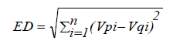 ------ Equation 4.1

where Vp and Vq be the feature vectors of image P and query image Q respectively with size 'n'. Such consideration of only those major feature vector coefficients which contribute to most of the energy in the image is what distinguishes this comparative study from the ones in Kekre's approach which utilize reduced percentage of feature vector coefficients irrespective of their contribution to the image energy[2].

The technique proposed here splits the frequency domain image i.e. after applying the complete transform for efficient retrieval.

**4.2.5. Calorie Calculation Phase**

Having identified what the food item is by the aid of feature extraction phase, an output string would have the name of that food item. This string would then be searched in the pre-built nutrition table and the corresponding calorie value would be added to total calorie value of your entire meal ingredients.

|  |  |
| --- | --- |
| **Food Items** | **Calorie Value (in kcals)** |
| Apple | 130 |
| Tomato | 30 |
| Potato | 110 |
| Banana | 80 |
| Bread | 250 |
| Pomegranate | 100 |
| Orange | 80 |
| Green Capsicum | 40 |
| Papaya | 55 |

Figure 4.3 Nutrition Table

The above table consists of few of the food items we have considered in our scope.

For instance, the meal image consists of 4 items, one apple, two tomatoes, and a banana would calculate the total calorie value of the meal as 270(in kcals).

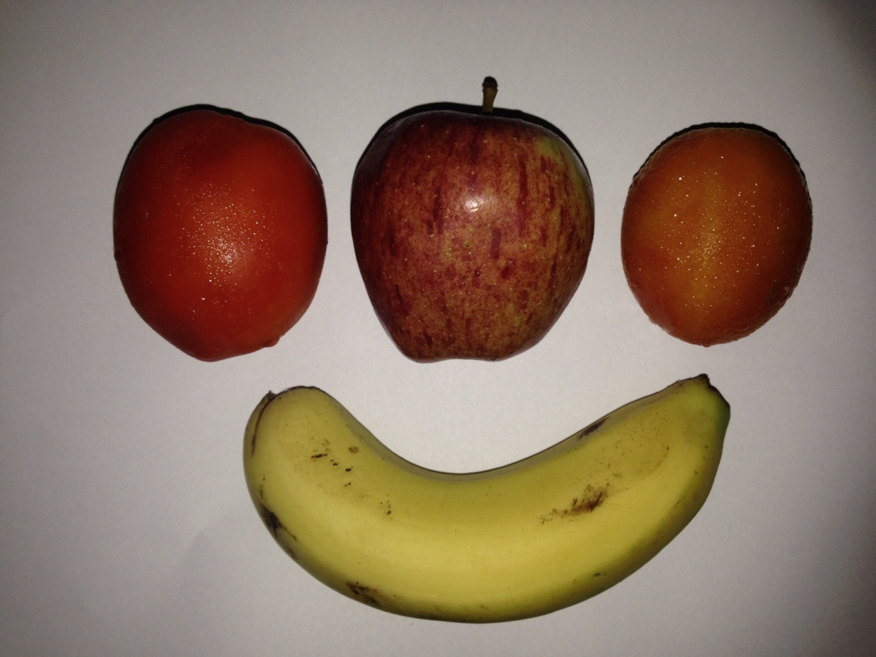

Figure 4.4 Input Image

**4.3 GUI Design**

GUI would help to easily manipulate and use the approach and not indulge with the code and data directly. A simple design to show how will the input be accepted and the total calorie amount would be generated.

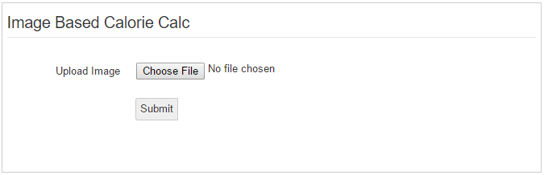

Figure 4.5 Screen 1 (Input)

Screen 1 would have just one mandatory field which would choose the path to the corresponding path of the image.

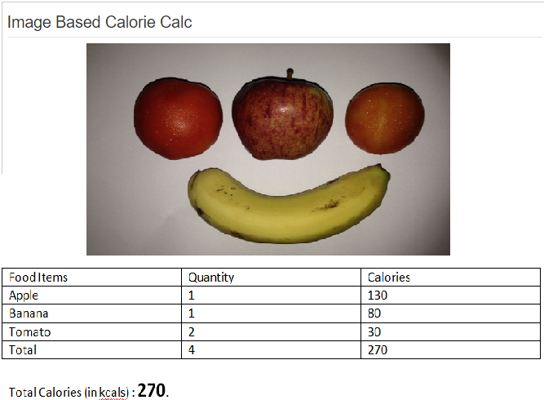

Figure 4.6 Screen 2 (Output)

Screen 2 would have a table consisting of three fields food items, quantity and calories. Accordingly the final result is generated.

**Chapter 5**

**Implementation Plan**

Month 1 (June 2015):

Analysis of existing solution were undertaken and realised altogether in this particular month.

Month 2 (July 2015):

Few approaches in order to implement Noise Reduction and Shadow Removal were undertaken and realised altogether in this particular month.

Month 3 (August 2015):

The task and enterprise as to accomplishing Feature Extraction was undertaken.

Month 4 (September 2015):

The task and enterprise as to accomplishing Feature Extraction will be undertaken and continued altogether in this particular month.

Month 5 (October 2015):

Various segmentation algorithms will be studied to understand their usability in our project.

Month 6 (November 2015):

Coding to accomplish a selected VQ Segmentation will be continued in this particular month.

Month 7 (December 2015):

The task and enterprise as to accomplishing Resizing will be undertaken and realised altogether in this particular month.

Month 8 (January 2016):

Integration of all the modules which were made with respect to their corresponding phases will be undertaken.

Month 9 (February 2016):

Formulation of Nutrition Table and database query processing will be accomplished as the final step of our project.

**References**

[1] S. Anushadevi, 'Calorie Measurement Of Food From Food Image', International Journal on Applications in Information and Communication Engineering Volume 1: Issue 7: July 2015, pp 14-17. www.aetsjournal.com

[2] H.B. Kekre, Archana B. Patankar, Aniruddh Munde, ' Energy based Comparative Study of CBIR Techniques and a Novel approach of Image Splitting in the Frequency Domain for Efficient Retrieval', International Journal of Computer Applications (0975 – 8887) Volume 41– No.13, March 2012

[3] Natta Tammachat, Natapon Pantuwong, ' Calories Analysis of Food Intake Using Image Recognition', 2014 6th International Conference on Information Technology and Electrical Engineering (ICITEE), Yogyakarta, Indonesia

[4] Dr. H. B. Kekre, Tanuja K. Sarode, “New Clustering Algorithm for Vector Quantisation using Rotation of Error Vector”, International Journal of Computer Science and Information Security, Vol. 7, No.3, 2010

**Acknowledgement**

We would like to express our special thanks of gratitude to our professor, Dr. Archana Patankar who gave us the opportunity to do this project on the topic CBIR and make the Calorie Calculator.

We would like to thank our Principal, Dr. G. T. Thampi and our head of department,

Mr. Jayant Gadge for the learning environment provided at Thadomal Shahani Engineering  College.

We would like to thank all our B.E. lab assistants have been of great help to us while researching on the topic, and availing us with all the tools required for designing our system.

Sincere thanks to everyone who have helped us gain knowledge and helped us to work on this project.